One of the Strongest, Toughest and Fastest High School Teams in Texas is Back for Another Season!
Who Are We? | Our Accomplishments
- MHS Swim & Dive Team (Magnolia, Texas)  - 50+ Dedicated Athletes (Swimmers and Divers)  - 2021 Women’s Swim Public School Coach of the Year (Vype High School Awards)  - Represent MHS at district, regional and state meets  - Supported by a parent-governed, booster club  - Part of a strong aquatics community in Magnolia, Texas  - Shared facility with multiple aquatics clubs (100s of visitors daily) | - 2017 Texas UIL 5A Girls State Champions  - 3-time Texas UIL 5A Girls State Runner-Ups  - 8-time 5A Girls District Champion  - 2-time 5A Boys District Champion  - 3- time Girls Region Champions State Champions  - Multiple 5A District and Region Individual titles  - Numerous All-State Academic and Athletic Honors  - Multiple Division I, II, and III College recruits
SPONSORSHIP LEVELS
Bronze Sponsor - $250
- Sponsorship recognition and ¼ page ad in our Senior Night and Banquet Programs
- Framed sponsor appreciation certificate
Silver Sponsor - $500
- 16” x 10” display of company name/logo in the Michael D. Holland Aquatic Center’s lobby
- Logo on MHS Booster Club Website (www.mhsswimdiveboosterclub.com) linked to your website
- Sponsorship recognition and ½ page ad in our Senior Night and Banquet Programs
- Framed sponsor appreciation certificate
Gold Sponsor - $1,000
- 4’ x 6’ vinyl banner display of company name/logo in the Michael D. Holland Aquatic Center’s pool area
- Logo on MHS Booster Club Website (www.mhsswimdiveboosterclub.com) linked to your website
- Sponsorship recognition and full-page ad in our Senior Night and Banquet Programs
- Promotion on our Facebook and Twitter accounts.
- Named in our meet recap stories posted on social media and websites (booster club and MHS Athletics)
- Framed sponsor appreciation certificate
T-Shirt Sponsor - $1,750 - Logo on back of 100+ parent shirts plus GOLD Level benefits
Please complete this form, select your sponsorship level and make your check payable to MHSSDBC. Please mail form and check to MHSSDBC – P.O. Box 1681, Magnolia, TX, 77353. If you’re submitting a logo, email a high-resolution format to mhsswimanddiving@gmail.com.
All submissions need to be made no later than 9/1/2021 in order to meet printing deadlines.
Family/Sponsor Name: __________________________________________________________
(Clearly print name as you wish for it to appear on all recognition items)
Contact Name: ____________________________________ Contact Number: _____________________________
Contact Email: ______________________________ Sponsor Website: _____________________________________
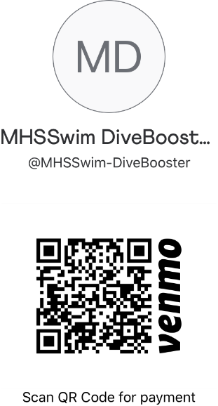
Sponsorship Levels (check the level you want)

T-Shirt Sponsor - $1,750

Gold Sponsor - $1,000

Silver Sponsor - $500

Bronze Sponsor - $250

T-Shirt Sponsor level is limited to ONE. Your company will have their logo on full display on over 100 parent’s backs. Seize this opportunity!

Donations may be tax deductible. The Magnolia High School Swim & Dive Booster Club is a non-for-profit charitable organization under 501(c)(3). As a result, your donation may be tax deductible as a charitable contribution. Please keep a copy of this form and the receipt we mail you for your records.

