One of the Strongest, Toughest and Fastest High School Teams in Texas is Back for Another Season!
Who Are We? | Our Accomplishments
- MHS Swim & Dive Team (Magnolia, Texas)  - 50+ Dedicated Athletes (Swimmers and Divers)  - 2021 Women’s Swim Public School Coach of the Year (Vype High School Awards)  - Represent MHS at district, regional and state meets  - Supported by a parent-governed, booster club  - Part of a strong aquatics community in Magnolia, Texas  - Shared facility with multiple aquatics clubs (100s of visitors daily) | - 2017 Texas UIL 5A Girls State Champions  - 3-time Texas UIL 5A Girls State Runner-Ups  - 8-time 5A Girls District Champion  - 2-time 5A Boys District Champion  - 3- time Girls Region Champions State Champions  - Multiple 5A District and Region Individual titles  - Numerous All-State Academic and Athletic Honors  - Multiple Division I, II, and III College recruits
SPONSORSHIP LEVELS
Bronze Sponsor - $250
- Sponsorship recognition and ¼ page ad in our Senior Night and Banquet Programs
- Framed sponsor appreciation certificate
Silver Sponsor - $500
- 16” x 10” display of company name/logo in the Michael D. Holland Aquatic Center’s lobby
- Logo on MHS Booster Club Website (www.mhsswimdiveboosterclub.com) linked to your website
- Sponsorship recognition and ½ page ad in our Senior Night and Banquet Programs
- Framed sponsor appreciation certificate
Gold Sponsor - $1,000
- 4’ x 6’ vinyl banner display of company name/logo in the Michael D. Holland Aquatic Center’s pool area
- Logo on MHS Booster Club Website (www.mhsswimdiveboosterclub.com) linked to your website
- Sponsorship recognition and full-page ad in our Senior Night and Banquet Programs
- Promotion on our Facebook and Twitter accounts.
- Named in our meet recap stories posted on social media and websites (booster club and MHS Athletics)
- Framed sponsor appreciation certificate
T-Shirt Sponsor - $1,750 - Logo on back of 100+ parent shirts plus GOLD Level benefits
Please complete this form, select your sponsorship level and make your check payable to MHSSDBC. Please mail form and check to MHSSDBC – P.O. Box 1681, Magnolia, TX, 77353. If you’re submitting a logo, email a high-resolution format to mhsswimanddiving@gmail.com.

Sponsor Name:
(Clearly print name as you wish for it to appear on all recognition items)
Contact Name:
Contact Number:
Contact Email:
Sponsor Website:
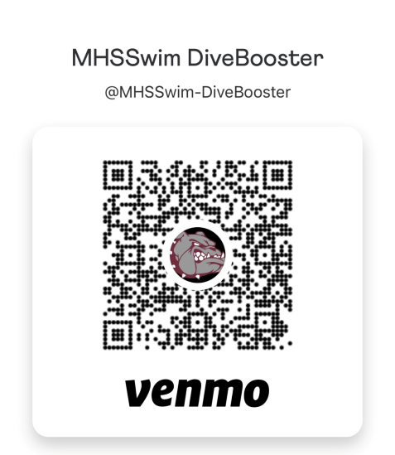
Sponsorship Levels (check the level you want)

T-Shirt Sponsor - $1,750

Gold Sponsor - $1,000

Silver Sponsor - $500

Bronze Sponsor - $250

Donations may be tax deductible. The Magnolia High School Swim & Dive Booster Club is a non-for-profit charitable organization under 501(c)(3). As a result, your donation may be tax deductible as a charitable contribution.

